Sascha Liebermann  Citizen’s group „Freedom, Not Full Employment“,  Germany,  www.freiheitstattvollbeschaeftigung.de  info@freiheitstattvollbeschaeftigung.de | 

Bringing UBI into the National Debate

Experiences of German Activists

How has it all developed – how did we begin?
It has been about 3 years now that one can speak of a public debate on an Unconditional Basic Income (UBI) in Germany. This can be regarded as a great success for all the activists who have tried to spread the idea and put it on the agenda. It is also a great success in view of the wide-spread scepticism that alternatives to workfare are possible.
Since 2006 political parties, business associations and trade unions have come under pressure to deal with the issue as well, so that more and more workshops and public forums have taken place where the pros and cons are discussed. Media coverage has been stunning as well though superficial. My experience with journalists tells me that they seem not to understand their profession as one serving the people to help them form an opinion. The effects an UBI would have in turning the purpose of welfare and other institutions upside down is rarely taken into consideration by media coverage.
How has it all developed? Which means were helpful in drawing people’s attention to the UBI as a powerful alternative to prevailing welfare regulations in Germany? What barriers to debate are still widespread, and what arguments are put forth by opponents such as employers and trade unions or other relevant groups?
In my talk I would like to give you a very brief account of the debate in Germany from my perspective. So I will not deliver a paper giving you an overview taking into account all active groups and developments. Instead I will look at it from my point of view as part of the group “Freedom, Not Full Employment”, which has been involved in the debate on an Unconditional Basic Income since December 2003.
How did we begin? What were the difficulties?
Working together as researchers at the universities of Dortmund and Frankfurt for several years we had been doing research on issues like work ethics, labour market, life-conduct under conditions of modernity, gender etc. Almost all of us studied in Frankfurt and three of us lived there. We were strongly influenced by the sociologist Ulrich Oevermann. It was he who confronted us with the idea of the UBI in the mid-nineties, although he was not familiar with existing debates in BIEN or other more academic circles at that time. UBI was not on the German agenda, it was only known among academics, going back to some discussion in the eighties. Sometimes the Green Party is considered to have been in favour of an UBI in the eighties, which is not true. They envisaged something like a guaranteed income at that time but not of an UBI provided from the cradle to the grave. The idea’s attractiveness seemed to have dissipated except for a few groups like the one proposing an “Existenzgeld” (“Money to exist”), which in some respects comes pretty close to an UBI.
To us the idea was solely academic in the nineties, and we had no intention of suggesting it as an alternative to existing welfare policies in Germany until early 2003 when German chancellor Schroeder set up the agenda 2010, introducing workfare policies as a remedy for high unemployment. What is little known is that (I guess it was two years earlier), the Prime Minister of the State of Hessia travelled to Wisconsin in the US and brought back as a souvenir the Wisconsin Works concept. And in 1998 the city of Frankfurt introduced the concept of “Praeventionshelfer” (“prevention assistant”) to patrol in the city, equipped with red jackets and baseball caps. Their task was to oversee issues of order in public places. The long term unemployed were committed to do that job. Compared to what happened under the Schroeder government it was harmless. Schroeder and the so called Hartz-Commission (name given after the chair ‘Peter Hartz’, former Volkswagen-manager), an advisory board to the chancellor, delivered a report on how to create jobs and make the labour market more flexible. Workfare was widely celebrated as the best way out of unemployment. The trade unions were involved in the commission and signed the report as well.
It was this turn in German politics which made us think of bringing our academic findings combined with arguments for the UBI into the public. We felt a civic duty to propose an alternative. That we had to do something, the feeling was just there. What we also knew was that another academic association was not necessary, since there was BIEN, and a debate in the public by appealing to our fellow citizens was the only way to get more attention for the UBI.
But, how to do it? How to reach our fellow citizens? Academic and public discourse are like two different worlds. Not only because of terminological quirks. We had to get rid of academic language to a certain extent. Arguments are indispensable to enable people, who never came across the idea, however, to understand what it is about. We had no reputation that could help us to open doors, to gain the attention of journalists – concise arguments were our only means.
But how to do it practically?
Obviously one needs a website to provide some information. Papers were written, shorter and longer ones in which our diagnosis was outlined and the UBI evolved as an alternative. We also tried to sketch what a UBI would change by substituting the ideal of doing paid work by an individual to leading a self-determined life. What would it change for families and single parents, young people who are under today’s pressure to get into the labour market, the education system and education itself, economically weak regions, working conditions for researchers and artists, social work, care work, volunteering, financial markets (because people won’t necessarily need old-age provisions), sustainable development and last but not least democracy and democratisation (which is hardly mentioned in the debate). Furthermore a whole range of labour-focused terminology would become obsolete. Without any obligation to do paid work, with other activities being equally appreciated no one could be ‘out of work’. ‘Time off’ would not exist any longer, hence leisure would become a common thing.
Of course, the UBI is not, as Carole Pateman pointed out, a panacea, but it has an impact on all fields of life and on all institutions. Why? Because it turns welfare upside down. Instead of guiding people back into the labour market, instead of predefining what the aims of life must be, it opens up opportunities for a self determined life.
Back to the question above: how can we reach the people? Which slogan would be appropriate to attract people’s attention? Who would be attracted by a slogan saying “Proposal for an Unconditional Basic Income”? We found it too academic, and something that only insiders would understand. Above that the UBI is not the goal, it is the means to a goal: freedom. Moreover it had to fit the particular German debate. To find a useful slogan was a strain, and it took quite some time. One day three of us were standing in front of a computer revising the theses again – which took nine months all in all -- and all of a sudden one of us exclaimed: let’s call us “Freedom, Not Full Employment”. It corresponded to what the UBI stands for – freedom – and opposed to what was the prevalent catch word in Germany’s workfare debate: full employment – as political goals. Full employment had become a goal in itself regardless of what it did to people’s opportunities to choose. Consequently freedom had become the opposite of “full employment,” also connected to one slogan of the CDU, namely, “social is, what creates labour”.
This text-overloaded poster (see below) was put up first in Frankfurt in December 2003 in 50 underground stations. We had to rent the places to be sure the posters would be there for ten days. We campaigned in other cities as well: in Berlin (2004), again in Frankfurt, Dortmund, Cologne and Hamburg (all in 2005). To bear the costs we asked people to donate by spreading our appeal for support via our newsletter. Most of the donations came from people we have never seen or talked to.
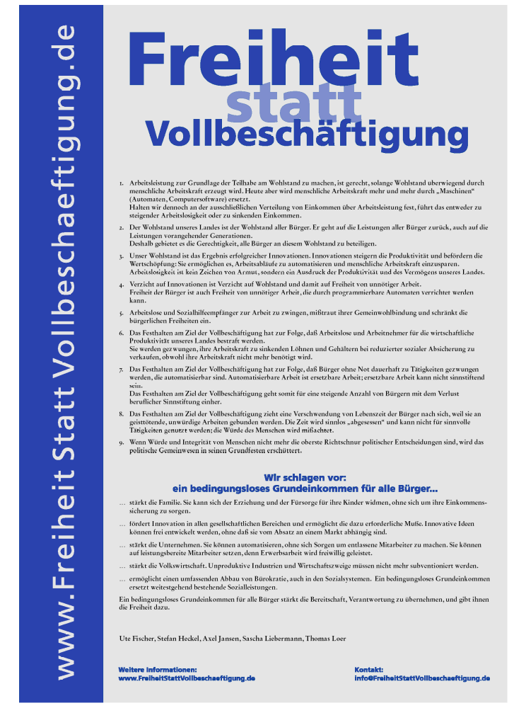
First poster in 2003 (http://freiheitstattvollbeschaeftigung.de/pdf/FreiheitstattVollbeschaeftigung.pdf;
(English: http://freiheitstattvollbeschaeftigung.de/en/index.htm)
We discussed the layout several times. On the one hand people should be able to recognize what it is all about when seeing the posters. On the other hand text-overloaded posters could be counterproductive. We opted for the text-overloaded ones so that they could be distinguished from commercial advertisements. And, as you will see, it worked surprisingly well.
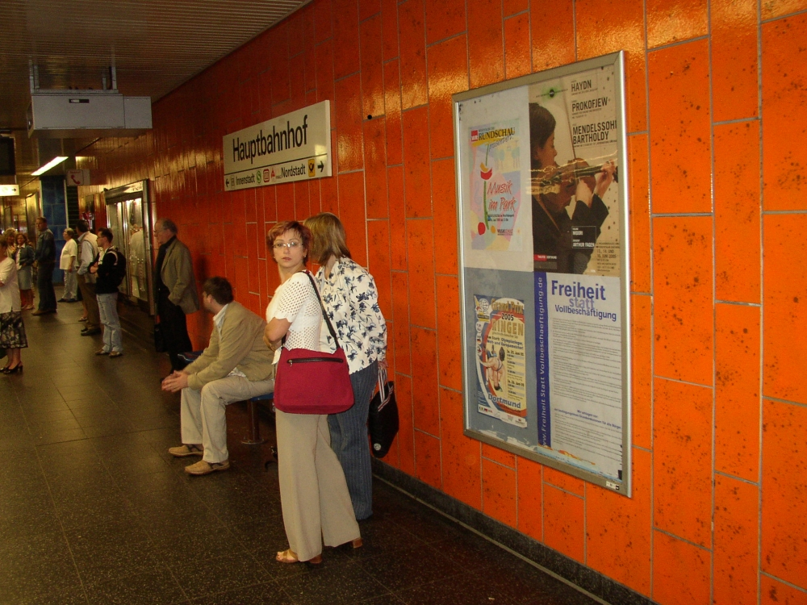
More photos: http://freiheitstattvollbeschaeftigung.de/plakataktion.htm
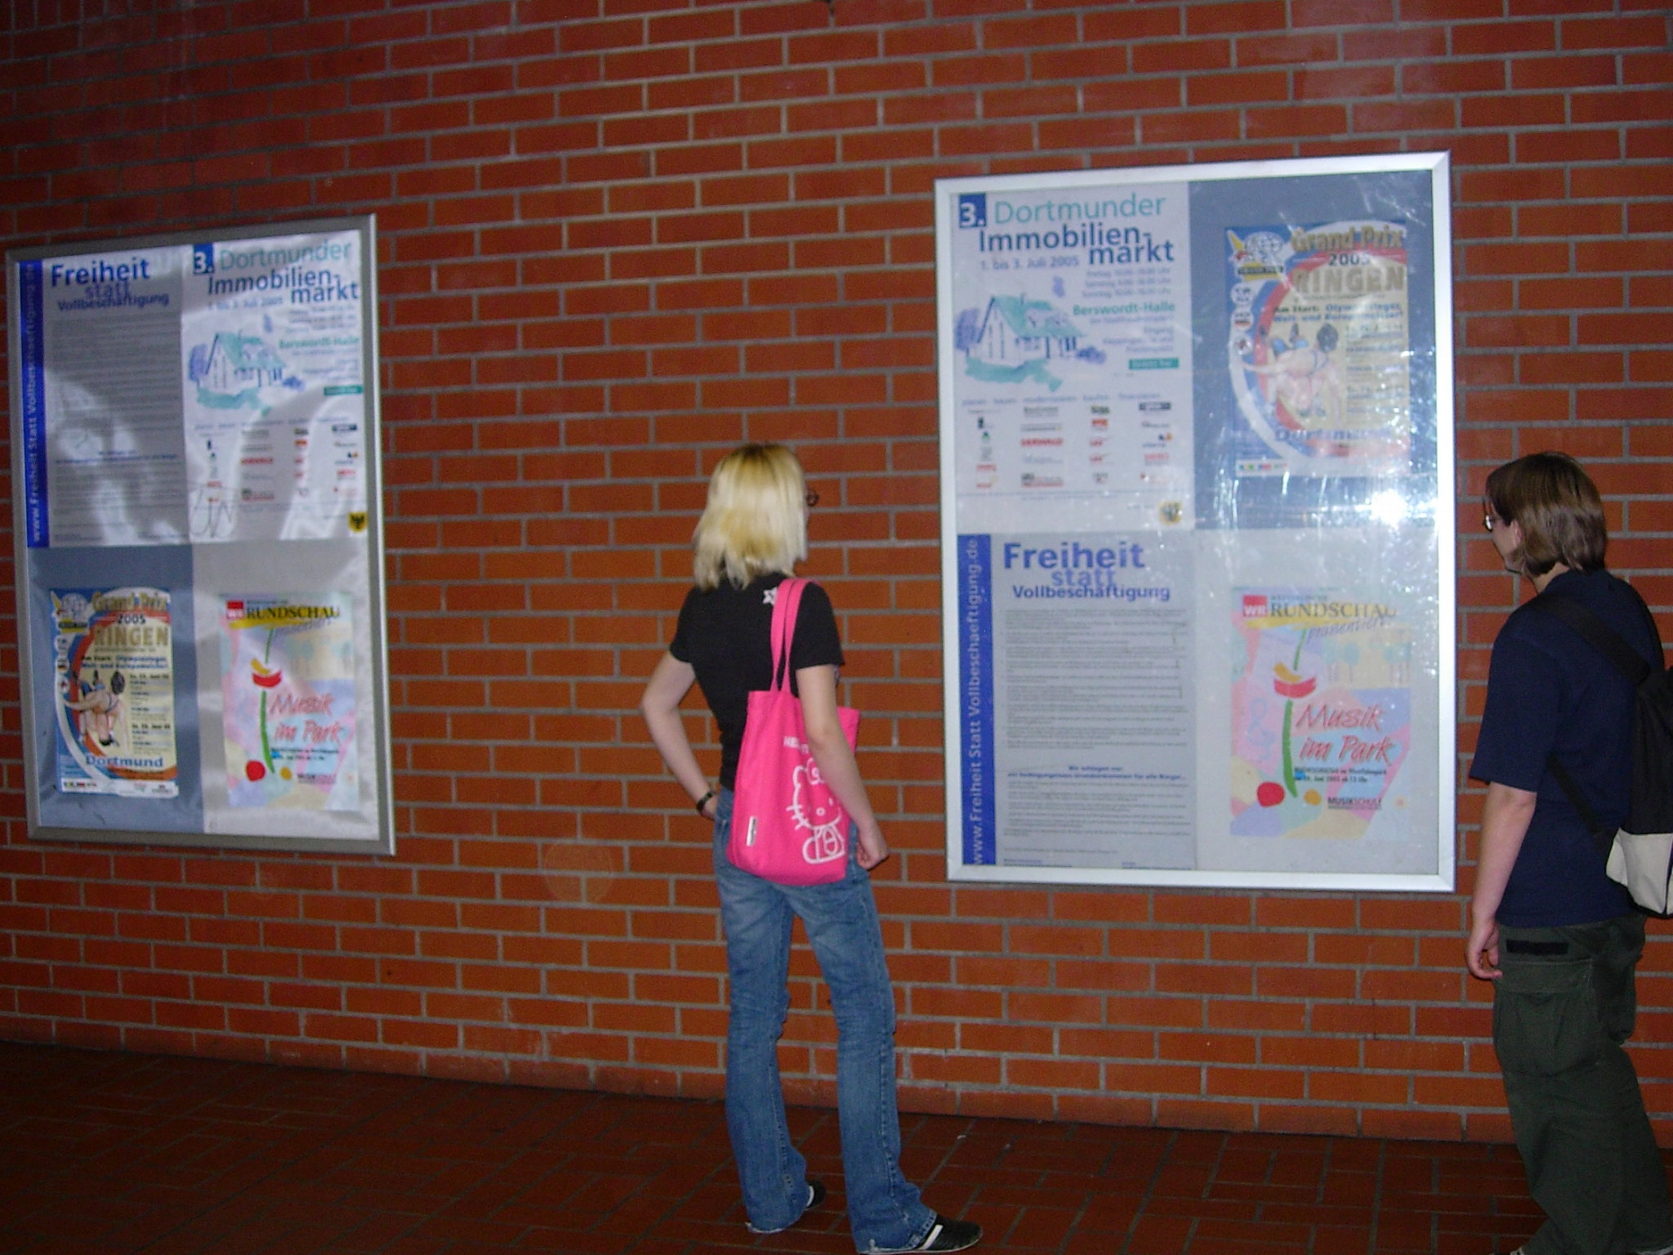
Underground, Dortmund 2005

A few months earlier we activated our website onto which we put the poster as a front page; the layout has slightly changed since 2003. In 2006 we added a weblog for comments on daily news related to the UBI debate in Germany.

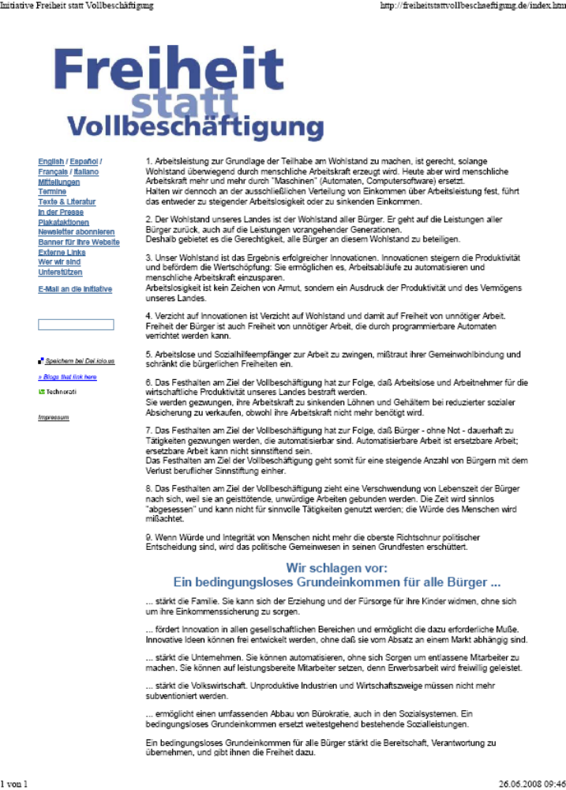
Website, front page: http://freiheitstattvollbeschaeftigung.de/index.htm

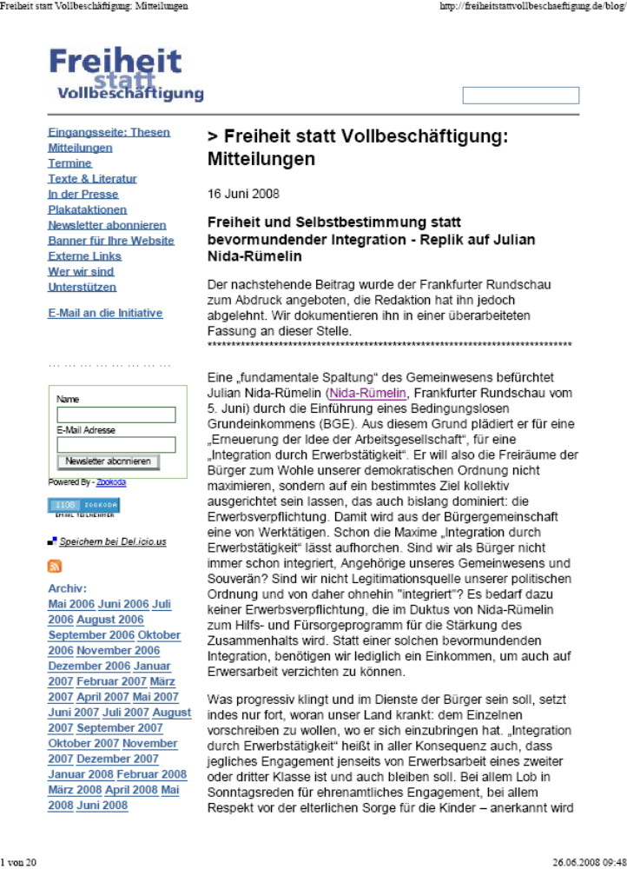
Website, blog: http://freiheitstattvollbeschaeftigung.de/blog/

The response to the posters in Frankfurt was amazing. Despite being convinced of the idea’s power, we were sceptical as to whether it would find any response at all – the UBI was against all currents at that time.
Many emails were sent to us, some complaining about the communist idea that would wreck our economy. Others accused us of being servants to neoliberal ideology and capitalism. In many emails people expressed a feeling of relief, seeing a light at the end of the tunnel. The idea’s power is to give a vision of where to go, how life could be compared to the workfare-world.
A public dialogue was evoked by the posters as you see here:
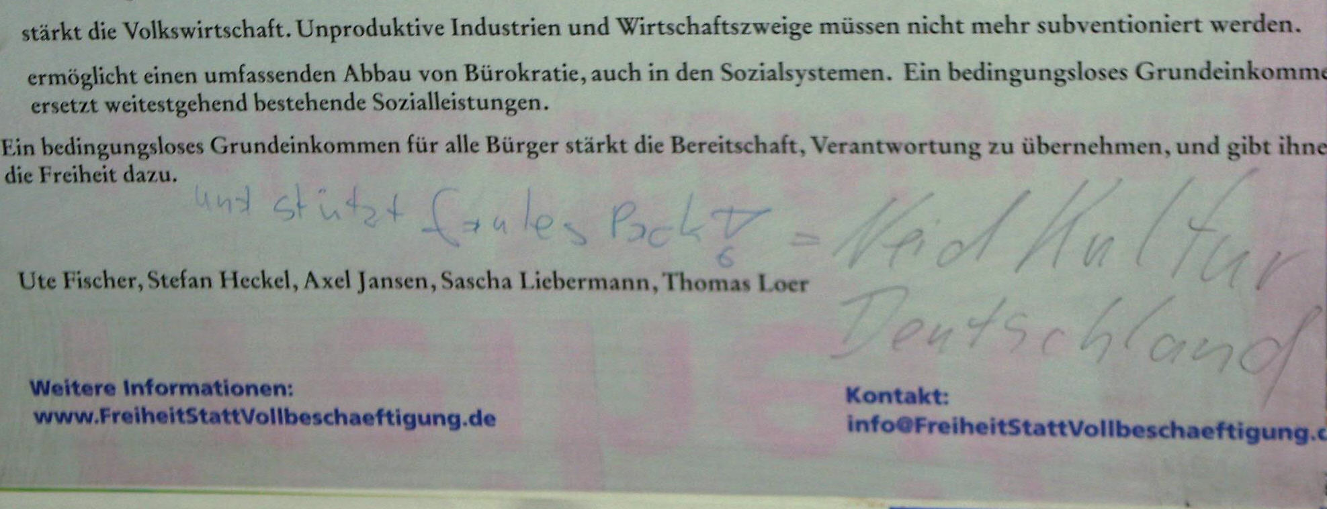
“and backs up lazy pack = culture of envy Germany”
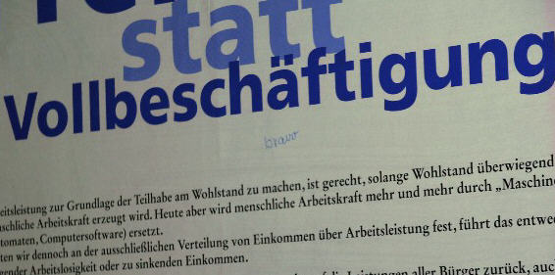
“bravo“
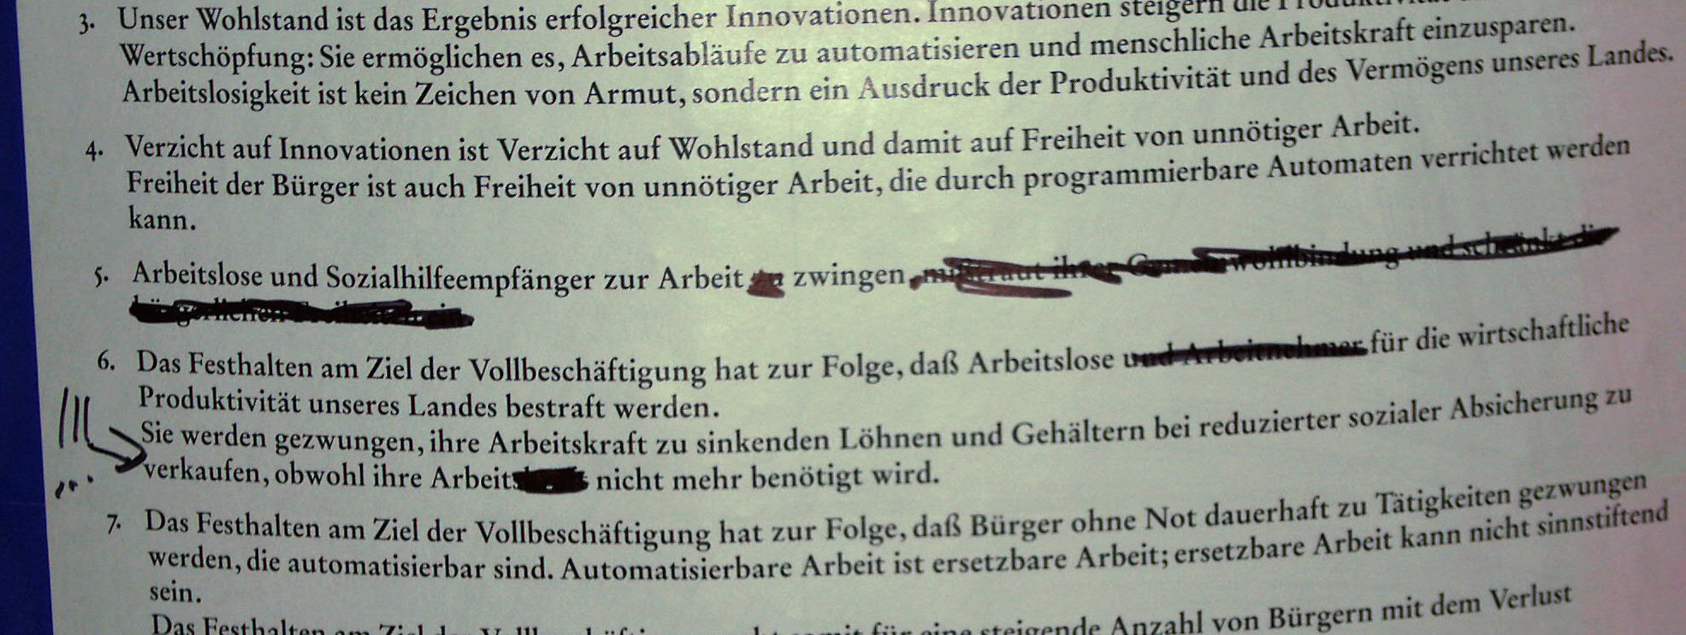
Poster revised – all photos: Underground, Frankfurt, December 2003
http://freiheitstattvollbeschaeftigung.de/plakataktion.htm
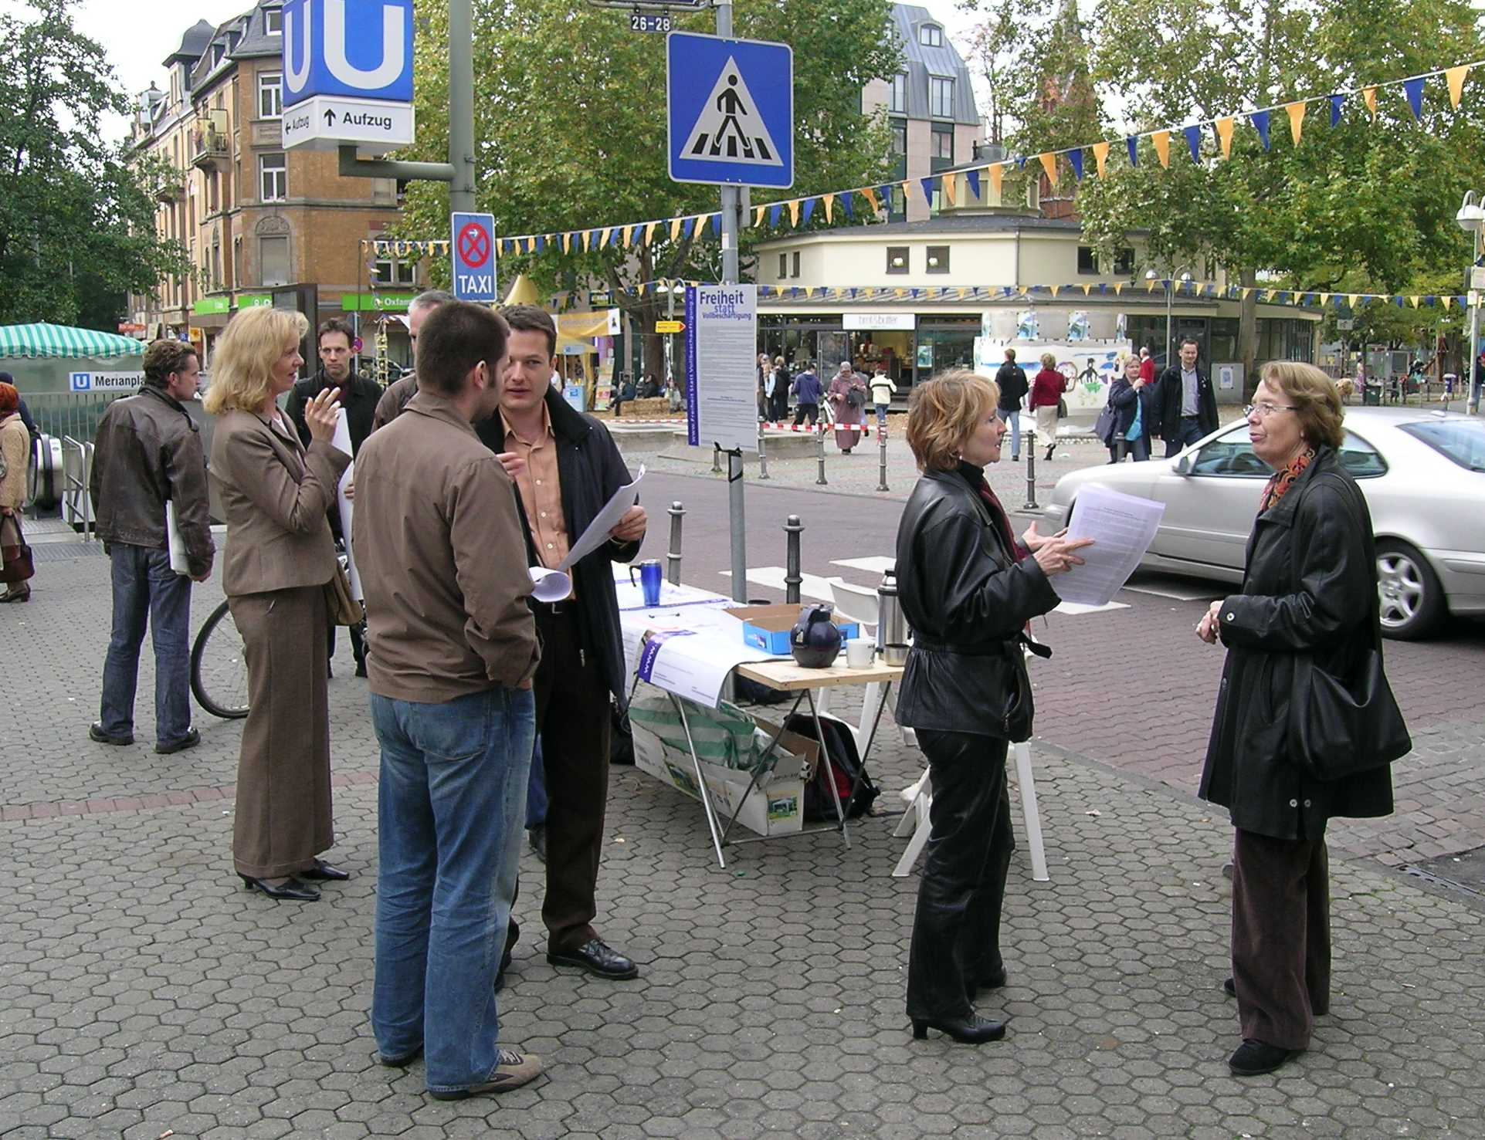
Street campaigning, Frankfurt, summer 2004
First media contacts followed immediately after the first poster campaign. Journalists saw the poster in the Underground station and wrote emails or phoned us. German public TV programme 3Sat broadcasted a feature called “Hartz-Journey” alluding to the “Hartz-Commission”.
The last part of the feature used our slogan as a headline in March 2004 (see next page).
Even though first media contact was attained easily, it has been very difficult to publish articles in newspapers, even when replying to articles dealing with welfare reform or even the UBI. Newspaper journalists have been very hesitant to cover the idea regularly.
In summer 2004 there were only a few activists. In emails we were often asked by people from all over Germany how they could support the idea. We advised them to gather in local groups, to organize public lectures and panel discussions, providing a forum for public debate open to everyone. A lot of attempts to found local groups failed. Obviously it is one thing to be interested in an idea, but it is another thing to get involved with it. Especially in the first two years the amount of emails we received was very high, it was time consuming to answer but indispensable to respond personally to objections and questions. People have had a strong wish to know who we are, whether we belong to a party or if we are an association pursuing particular interests. Transparency of what we argued for and who we are has been very important, so we added information about us. In public debate the value of an idea depends a lot on how trustworthy its advocates are.

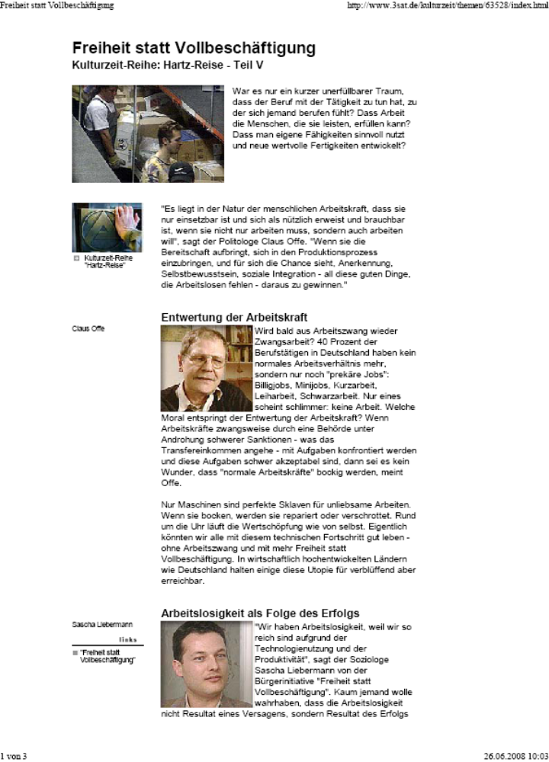
Public TV programme “3Sat, Kulturzeit”: http://www.3sat.de/3sat.php?http://www.3sat.de/kulturzeit/themen/62616/index.html

In summer 2004 the German affiliate to BIEN was founded. Here you see the new website launched at the end of 2007.

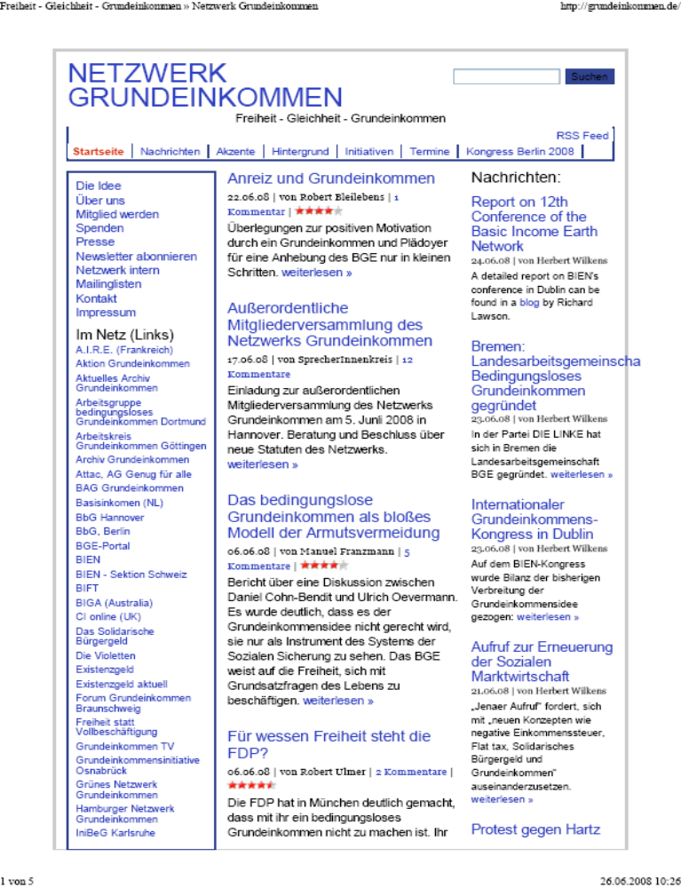
Website, homepage: http://grundeinkommen.de/

Another website (see below) set up by Wolfgang Roehrig has served as the biggest UBI archive, gathering a large amount of newspaper articles, TV programmes, brochures, leaflets, expert reports etc on the debate. It is called “Archiv Grundeinkommen” (http://www.archiv-grundeinkommen.de/) and is the most important website for those who want to know what has been happening in Germany.

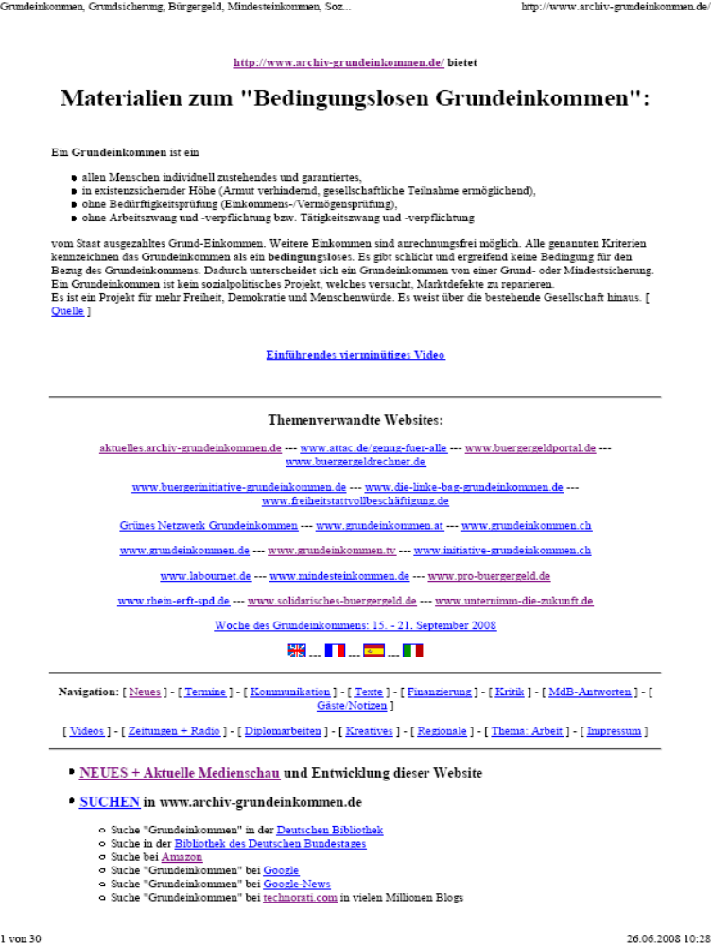
In late 2004 someone sent an interview by Goetz W. Werner, German business man and CEO of DM, in which he mentioned the UBI, published in a tempo (http://www.iep.uni-karlsruhe.de/download/a_tempo_Dezember_2004.pdf). It is a customer magazine edited by DM, the drugstore chain Werner has built. In early 2005 he gave an interview to the magazine “Brandeins” which was published under the title “We live under paradisiac conditions” in which he stressed the enormous economic wealth of western European countries being able to produce such a surplus of goods and services. Consequently, he said, we should introduce an UBI instead of treating welfare recipients as if they were inmates of an open prison. The same magazine picked the subject up again in the August 2005 edition using the Headline “Labour”, subtitling “Never Full employment again – We’ve got better things to do” (see next page).


“Labour - Never Full Employment again - We‘ve got better things to do!”
http://www.brandeins.de/home/inhalte.asp?MenuID=130&MagID=65&sid=su84176452143003944&umenuid=1

Werner’s commitment has been enormous, a door opener in many respects. He has helped to dispel suspicions that the UBI might be a communist idea, and today it is confronted less with objections of this sort. Werner attracted at lectures 1000-2000 people, which brought some critics to compare UBI supporters to religious sects or salvation movements. He has given, I reckon, about 60% of all lectures on UBI in Germany most of them public talks. He published two books, the first one in 2006 “A Reason for the Future: Basic Income” (translated into Japanese), and a second one in 2007 “Income for All”. 50000 copies of the first and 30000 of the last one have been sold. In autumn the paperback edition of “Income for all” will be released.
In 2005 the debate advanced a lot and media coverage increased: from well-known daily newspapers like the Frankfurter Allgemeine Zeitung, the Sueddeutsche Zeitung, Die Welt to weekly newspapers like Rheinischer Merkur and Die Zeit to smaller ones like Tagesspiegel and taz, they all covered the debate. Media coverage had another peak in 2006, when the Prime Minister of the Free State of Thuringia published his proposal of a “Solidarity Citizen’s Income”(official translation, http://www.thueringen.de/en/citizens_income/). Apparently political parties as well as thinktanks and business associations could not refuse discussion any longer, the public debate had put pressure on them.

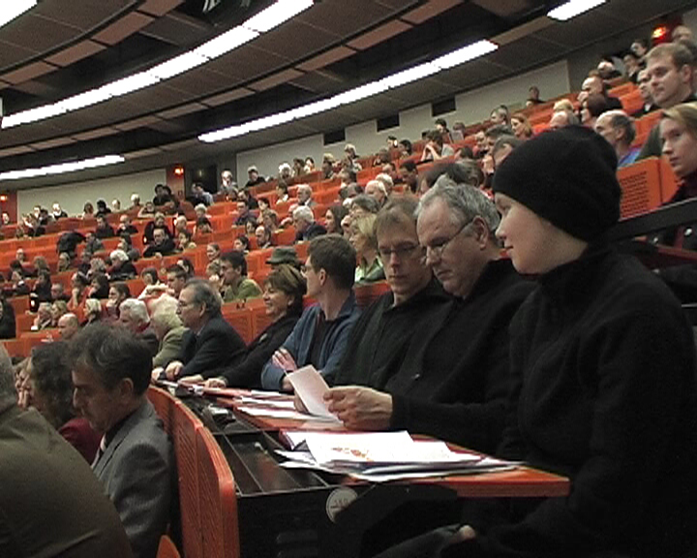
Panel discussion, University of Dortmund, about 400 people in the audience,
February 2006

There are discussions within all parties, more or less intense. But at least they have commented on the UBI proposal.
Others released readers, sometimes our slogan is used, as in the one edited by the Green Party of North Rhine Westphalia…


http://www.gruene-nrw.de/Soziales-und-Gesundheit.803+M5670d68f768.0.html
…and as did a feature on Goetz W. Werner on TV in late 2006:

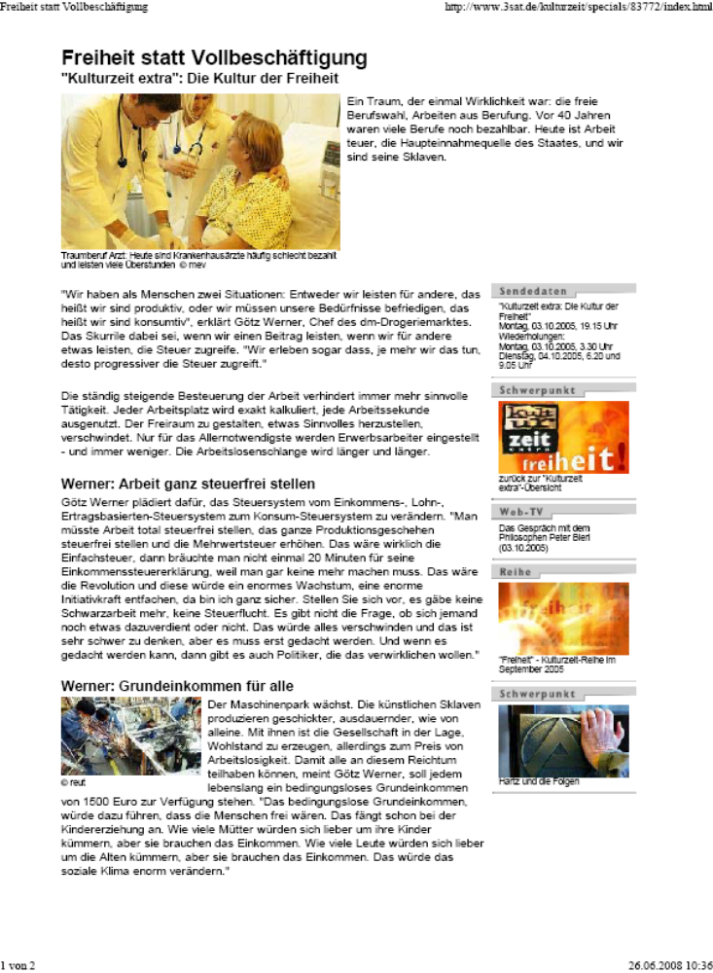
http://www.3sat.de/3sat.php?http://www.3sat.de/kulturzeit/specials/83772/index.html

So, it seems the wording is very important, and if a slogan hits a nerve, it is picked up to feature for example the UBI.
A new step to organize UBI activists was made with the release of the website “Forum Aktion Grundeinkommen” in November 2006 by Axel Jansen (co-founder of our group) and Manuel Franzmann.

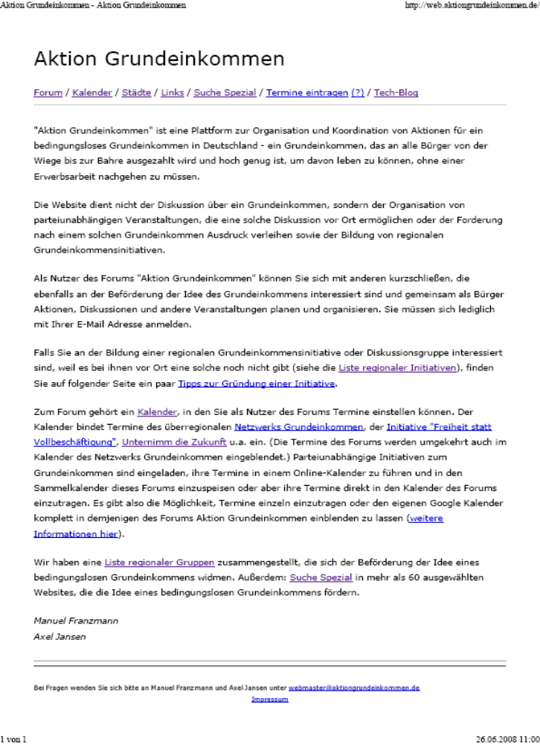
http://web.aktiongrundeinkommen.de/
The Website serves as a platform for supporters who are looking for like-minded people. It offers a bulletin board for groups to announce their activities and features a calendar gathering information about lectures, panel discussions and so on. It is the most important calendar available, and a lot of groups have integrated it into their websites.

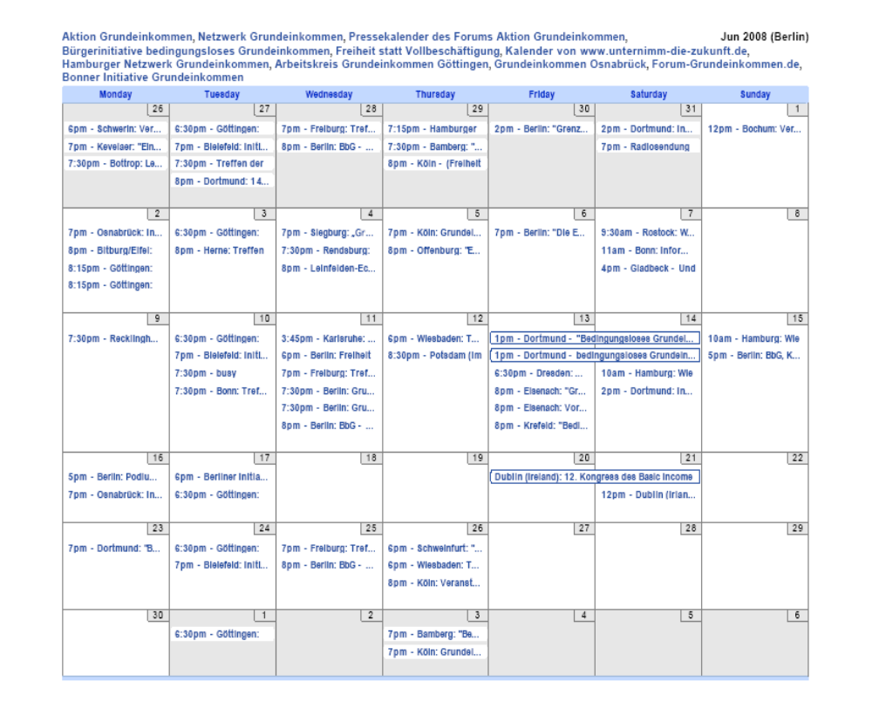

Calendar including almost all events related to the UBI in Germany
http://web.aktiongrundeinkommen.de/kalender

A nice feature the website offers is a map showing where groups are located:

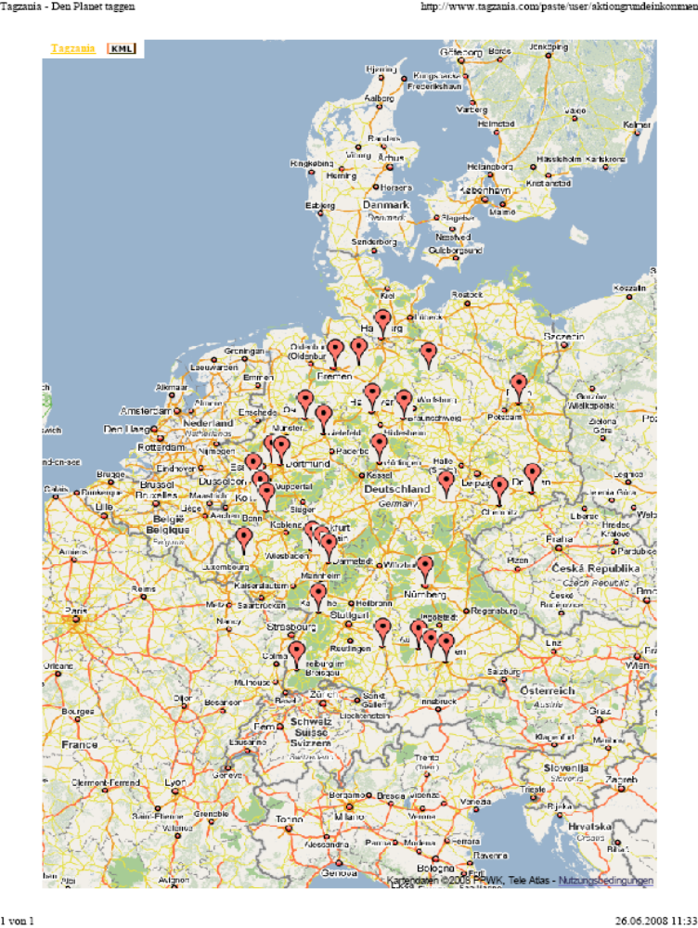

http://web.aktiongrundeinkommen.de/staedte

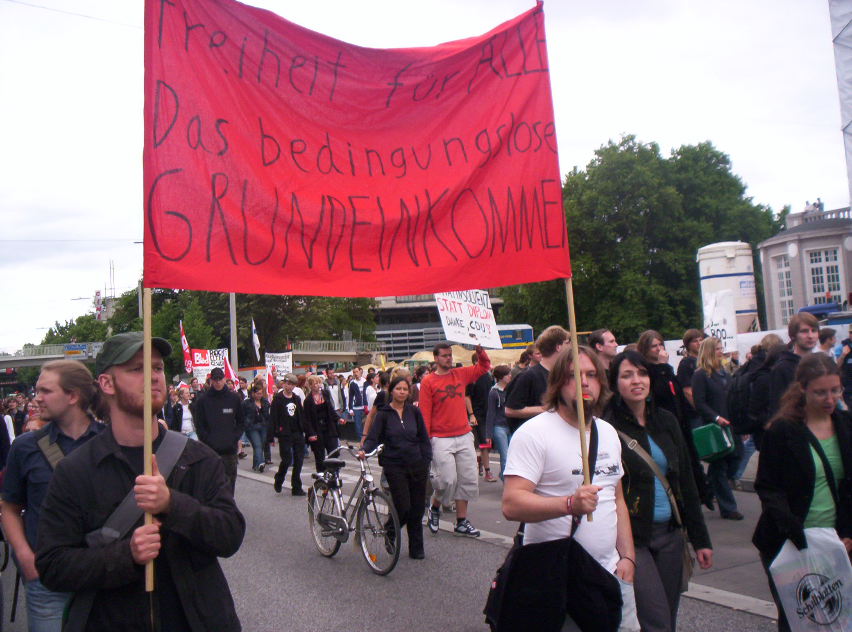
Freedom for all. Unconditional Basic Income, Bremen 2008

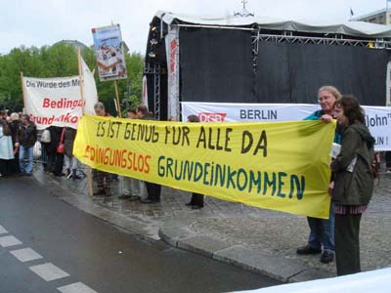
There is enough for all. Unconditional Basic Income, Berlin 2008

Meanwhile other groups also use posters to campaign:

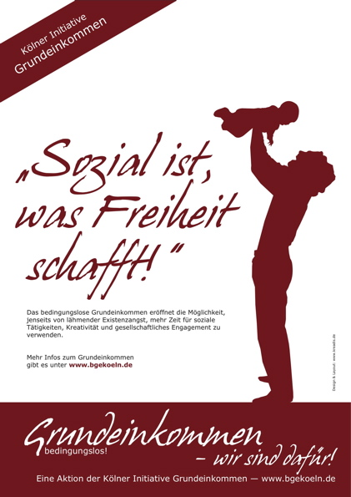
“social is what creates freedom”, campaign of local group in Cologne, 2007
http://www.bgekoeln.de/index.php?article_id=82

Journalists are still hesitant, though, and since 2006 one can observe a celebrity culture in the media concerning UBI coverage. Be it in newspaper articles, magazines or radio features they mostly rely on VIPs. It is rarely mentioned how many local groups there are.
Trade unions as well as Employer’s associations still oppose the idea. Beyond differences between more or less regulation concerning market policies there is a strong consensus on one point: we cannot leave it up to the individual how he or she spends its time.
To my mind the main obstacle to a wider response to the UBI in Germany has been the enormous mistrust in the individual you are confronted with in arguments against the idea. It is amazing how little people trust their own experience in leading a self-determined life already supported by institutional settings. The discrepancy between everyday life conduct and its interpretation is so huge. Volunteering is a common thing in Germany, too, and people just do it, but if it comes to this aspect in discussions it is sometimes scary what people say about their fellow citizens.
Instead of enabling freedom by opening up opportunities via UBI the pundits do not want to let go of “full employment”, e.g. to regulate what people should do with their life. They do not see, or don’t want to see, that the UBI allows a totally different understanding of occupation, whereby people could be fully occupied with whatever they wish to do, without being employed at all. “Full employment” would gain a completely different meaning.
Even the fact that democracy is fostered by the UBI does not impress the pundits. They often suspect that demoniac powers of capitalism or neoliberalism are bedazzling such people. But, if so, there would be no way out of theses powers’ empire.
Instead the success of the relatively few UBI activists shows how powerful arguments can become, if they are put forth in a pluralist way like the activists do; the success also shows how easily an alternative to our present understanding of life can be put on the agenda. At least people have to be willing to think about it.

TP?PT Paper presented to the 12P^{thP} BIEN-Congress on Inequality and Development in a Globalised Economy – The Basic Income Option, Dublin, June 20-21, 2008. I am grateful to Ian Copestake for his support in writing this paper.
As a UBI we understand an income guarantee provided form the cradle to the grave to every citizen and permanent resident, adults and children alike. It is an individual share of the common wealth of a country. Provided from the cradle to the grave it takes away the ideal of doing paid-work even the very liberal Negative Income Tax maintains. Only a UBI takes away stigmatizing effects of public compensations because it is not a compensation. The UBI should not be taxed at all. For more detailed arguments see “Defining the ‘Life Course’ or Enabling Autonomy? The Impact of an Unconditional Basic Income on Political Communities”. Conference From Welfare to Social Investment: Reimagining Social Policy for the Life Course, University of Melbourne (Australia), February 21-22, 2007 (http://www.public-policy.unimelb.edu.au/conference07/liebermann.pdf); “Political Communities – Constituents of Universalism”, 11th Congress of the Basic Income Earth Network (BIEN) „Universalism Strengthens Development“, University of Cape Town (South Africa), November 2-4, 2006 (http://www.epri.org.za/SaschaLiebermannFull%20Paper.pdf)

